SERVICE PERFORMANCE SUMMARY

A summary of my service performance for the summative review period is shown in the table below. As can be seen, I am highly active in University, Department and College, and Professional Service. I have also received several prestigious awards for my contributions.

**Service Performance, Annual S SCORE Rating, and Classification**

|  |  |  |  |  |  |  |  |
| --- | --- | --- | --- | --- | --- | --- | --- |
|  | | ‘17 | ‘18 | ‘19 | ‘20 | ‘21 | ‘22 |
| University | |  |  |  |  |  |  |
| 6. | People Analytics Lab Co-Director | X | X | X | X | X | X |
| 5. | Faculty Senate, CBA Representative |  |  | X | X | X | X |
| 4. | Research Council Member |  |  | X | X | X | X |
| 3. | Representing the Nicholls CBA at the ULS System Conference |  |  |  |  | X | X |
| 2. | Academic Master Plan Teaching Excellence Subcommittee |  |  | X |  |  |  |
| 1. | Courses and Curriculum Committee Member |  | X | X |  |  |  |
| Department & College | |  |  |  |  |  |  |
| 9. | Student SHRM Co-advisor | X | X | X | X | X | X |
| 8. | Academic Advising |  | X | X | X | X | X |
| 7. | Assurance of Learning Committee Member |  | X | X | X | X | X |
| 6. | Serving as Instructor of Record for Independent Studies, Internships, and Executive Education (MNGT 486, MNGT 469, CIS 485, CIS 490, MNGT 502) |  | X | X | X | X | X |
| 5. | Chair, Social Impact Committee |  |  |  |  | X | X |
| 4. | Faculty Supervisor for Travel Abroad |  |  |  |  |  | X |
| 3. | Galfalon carrier for Graduate Studies |  |  |  |  |  | X |
| 2. | Thesis Advisor |  |  |  | X | X |  |
| 1. | Management Search Committee Member |  | X |  |  |  |  |
| Professional | |  |  |  |  |  |  |
| 5. | Member of SIOP’s Open Science and Practice Committee |  |  | X | X | X | X |
| 4. | Editorial Board Member for *Journal of Business and Psychology* |  |  |  | X | X | X |
|  | Editorial Board Member for *Journal of Managerial Psychology* |  |  |  |  |  | X |
| 3. | Ad hoc Reviewing for Journals | X | X | X | X | X | X |
| 2. | Reviewing/Assisting with a Professional Conference |  |  |  |  | X |  |
| 1. | Invited Talks | X | X | X | X | X | X |
| Community | |  |  |  |  |  |  |
| 2. | Krewe of Christopher Member |  |  |  |  |  | X |
| 1. | Assisted the Bayou SHRM with Jeopardy Event | X |  |  |  |  |  |
| Honors & Awards | |  |  |  |  |  |  |
| 4. | Gerald Gaston Chair |  |  |  |  |  | X |
| 3. | Excellence in Research (CBA) |  |  | X |  |  | X |
| 2. | Recipient of travel funds for enhancing teaching effectiveness |  |  | X |  |  | X |
| 1. | Reviewer of the Year, *Journal of Business and Psychology* |  |  |  | X |  |  |
| S SCORE Facet Ratings | |  |  |  |  |  |  |
|  | Student services |  | 8.25 | 8.00 | 6.00 | 7.25 |  |
|  | Department, College or University |  | 8.00 | 8.50 | 8.50 | – |  |
|  | Professional & Community |  | 8.5 | 7.50 | 9.00 | 9.00 |  |
| S SCORE Performance Rating | | – | 8.25 | 7.70 | 8.10 | 8.48 |  |
| Classification | | – | High | High | High | High | – |
| Classification criteria for “High Performance” (High) as defined by Table 9 of the Faculty Development Plan requires a record of service which is above adequate/satisfactory performance. | | | | | | | |

SERVICE STATEMENT

As my performance summary reveals, I am quite willing to go out of my way to help the college and university community. I have mentored several students across the university via the People Analytics Lab (PAL) (e.g., Sara Avet from the Department of Psychology, Counseling and Family Studies; Kathryn Daigle, Bernard Wezeman, Eric Fedrowisch, Sandesh Sharma). I have served as a senator for the College of Business Administration (Fall 2019–Present), where I served on the COVID 19 Faculty Senate Taskforce (see <https://www.nicholls.edu/faculty-senate/>). I have served on several committees (e.g., Courses and Curriculum, Social Impact, Assurance of Learning). I have also led the development of the CBA’s Social Impact Themes (Fall 2021–2022), supervised several internships, and advised a student thesis.

*Evidence of Student Involvement in the PAL*

Omori, C. Daigle, K.*, & **Castille, C. M.** (2020, April). *What do these people do? Demographics and occupational features of MTurk* [Paper]. Society for Industrial and Organizational Psychology, Inc., 35th Annual Meeting (virtual). <https://www.siop.org/Annual-Conference/Conference-Schedule/Virtual-Program>

(conference canceled due to COVID 19)

Avet, S. (pictured below with Dr. Clune), Daigle, K., Wezeman, B., & **Castille, C. M.** (2018, April). *Comparing MTurk and the US Population’s Occupational Diversity: An Open Science replication of Mahmoud et al. (2017)* [Poster]. Scholars Expeaux hosted by Nicholls State University, Thibodaux, LA [[osf link](https://osf.io/a2q8k)]

* Winner of “Best Poster” offered by the College of Education

As additional evidence of impact via the People Analytics Lab, I submit the image below, which depicts the article published in collaboration with colleague Ann-Marie Castille and (student) Sandesh Sharma at the *Journal of Organizational Psychology*.

Castille, A.-M. R., Castille, C. M., & Sharma, S. (2021). The Incremental Value of Controlling for Covert Insufficient Effort Responding. *Journal of Organizational Psychology*, *21*(5). <https://doi.org/10.33423/jop.v21i5.4723>



**Demonstrations of Competence**

My activities have exceptional value for my profession. I am consistently called upon for my expertise and skill as a peer reviewer, having reviewed over 30 scholarly articles since 2017. A table summarizing my submission assignments by journal is provided below. For evidence of having completed these reviews, please see my [Web of Science](https://www.webofscience.com/wos/author/record/G-5352-2016) profile (<https://www.webofscience.com/wos/author/record/G-5352-2016>). A screenshot is provided below.[1]

**Professional Reviewing Summary of Completed Assignments**

|  |  |  |  |  |  |  |  |
| --- | --- | --- | --- | --- | --- | --- | --- |
| Journal | ‘17 | ‘18 | ‘19 | ‘20 | ‘21 | ‘22 | Total |
| *Journal of Managerial Psychology* |  | 1 | 1 | 2 | 3 | 2 | 9 |
| *Journal of Business and Psychology* |  |  | 2 | 2 | 2 | 2 | 8 |
| *Journal of Business Ethics* |  |  |  | 2 | 3 | 3 | 8 |
| *Applied Psychological Measurement* | 3 | 1 |  |  | 1 |  | 5 |
| *Management Decision* |  | 1 |  |  |  | 2 | 3 |
| *Current Psychology* |  |  |  | 1 | 1 |  | 2 |
| *Journal of Applied Psychology* |  |  |  | 1 | 1 |  | 2 |
| *Personality and Individual Differences* |  |  |  | 1 |  | 1 | 2 |
| *Social Behavior and Personality: An International Review* |  | 1 |  |  |  |  | 1 |
| *Frontiers in Psychology: Organizational Psychology[2]* |  |  |  | 1 |  |  |  |
| *Applied Psychology: An International Review* |  |  |  |  | 1 |  | 1 |
| *Sage OPEN* | 1 |  |  |  |  |  | 1 |
| *Journal of Organizational Effectiveness: People and Performance* | 1 |  |  |  |  |  | 1 |
| Total | | | | | | | 43 |

I also currently serve on the editorial board of two journals in the field of business, psychology, and management:

* [*Journal of Business and Psychology*](https://www.springer.com/journal/10869/editors) (2020–present)

* [*Journal of Managerial Psychology*](https://www.emeraldgrouppublishing.com/journal/jmp)(summer 2022–present).

*Evidence of Receiving the Reviewer of the Year Award*

The email below is the evidence I have to share regarding my reviewer of the year award.

*----Email from Steven Rogelberg -----*

Dear Eric, Daniel, Laura, Chris, Winfred, Susan, Richard, Enrica, Larissa  (CC associate and guest editors)

It is our distinct and total pleasure to inform you of your recognition as the recipient of the

**2020 JBP Reviewer of the Year Award**

This is no small feat.  There were well over **450 candidates** for this award.

Not only were your reviews returned in a timely manner, but most importantly the Editors’ ratings of the quality of your reviews were through the roof.   Your reviews were comprehensive, presented in a highly constructive and considerate tone, and very much captured the “big picture” issues associated with the manuscript you were evaluating.

Congratulations on this achievement.  Your service to the journal and more importantly to the profession as a whole is truly special.

I will make an announcement on the listservs as well.  **Please email me your affiliations so we can be sure we have it right.**

Kindest regards and congrats again,

Steven and Eden

--

---------------------------------------------------------------------------  
Steven G. Rogelberg, PhD   
Chancellor's Professor  
  
Professor, Organizational Science, Psychology, and Management  
Director, Organizational Science

President-Elect, Society for Industrial and Organizational Psychology

Editor, *Journal of Business and Psychology*

Associate Editor, Industrial and Organizational Psychology: Perspectives on Science and Practice

Secretary General, Alliance for Organizational Psychology

*----End Email -----*

Since 2019, I have served on SIOP’s Open Science and Practice Committee. My chief contribution to this committee concerned editing a column in our discipline’s publication (*The Industrial-Organizational Psychologist*, a journal in Cabell’s list) devoted to open science and open practice in IO psychology. Although the column does occasionally take invited submissions (two of which I’ve edited), I also provided entries (10 in total) since 2019. I have also led and helped organize a virtual conference co-sponsored by SIOP and CARMA called the [Open Science Virtual Summer Series](https://carmattu.com/siop-carma-open-science-virtual-summer-series/) (2021). My colleague, George Banks, was the lead instructor for the series. Meanwhile, I facilitated panel discussions with editors and representative of leading journals.

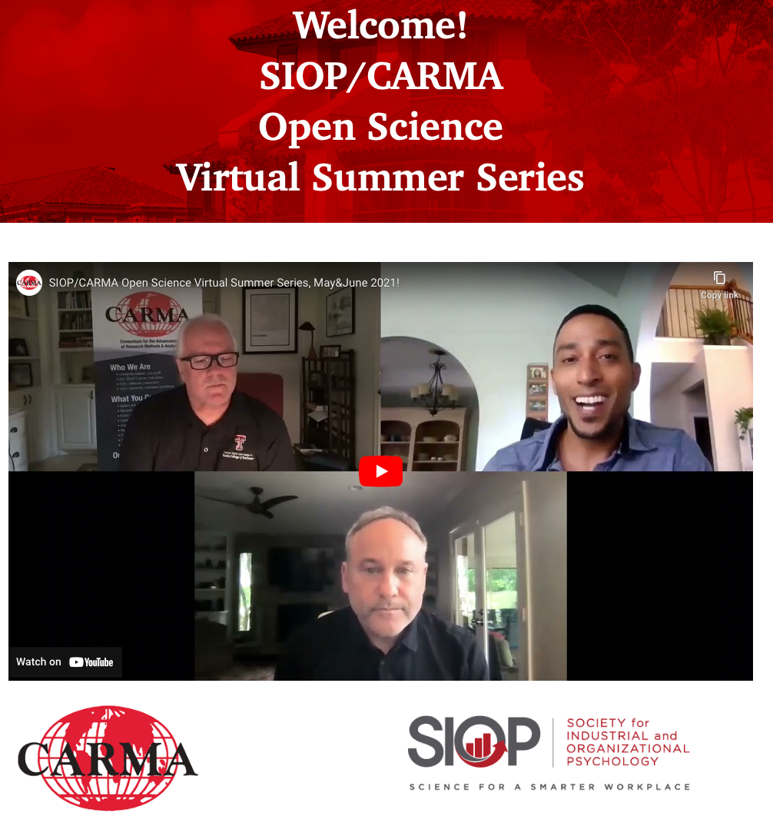

**Faculty Senate Representative**

Below are screenshots serving as evidence of my membership in the faculty senate as well as serving as a member of the COVID-19 Task Force.

**Plans Moving Toward Promotion to Full Professor**

Post-tenure review, after the allotted time has passed, I plan on applying for promotion to Full Professor. In order to be promoted to Full Professor, I must be exceptional in at least two performance categories – teaching, research, and/or service. Having reached the exceptional standing in research, I will focus more on service and teaching. Additionally, I must provide evidence of service as a mentor to junior faculty and of significant contributions to the progress of the department. I plan to make myself available to junior faculty as a mentor in teaching and research where my expertise can be valuable. As is evident in the following letter from my colleague, Mr. Adrien Maught, who endorsed me in my pursuit of the (attained) Gaston Endowed Professor of Management, I am already engaging in these activities.

Adrien Maught

Nicholls State University

November 24, 2021

College of Business Administration

Nicholls State University

University 906 East 1st St Thibodaux, LA 70301

**Subj: Gerald Gaston Endowed Professorship**

Dear Selection Committee:

I submit this LOR on behalf of Chris Castille regarding his efforts as a mentor and meaningful work within pedagogical strategies as they relate to the CBA strategic plan and mission.

As an organizational psychologist, I sought out Chris’ expertise to assist me 1) increasing engagement among my students and 2) more accurately assessing course learning objectives. In both areas, I was interested in finding innovative AND evidence based strategies. Chris has done a tremendous amount of work in the area of Team Based Learning (TBL). Specifically, Chris directed me to two works for reference:

* Team-Based Learning: Small Group Learning’s Next Big Step, Michaelson et al.
* Cooperation in the Classroom, Aronson et al.

Within these structures, students engage continually throughout the semester, working on various scaffolded deliverables. Among many purposes, this methodology allows for students to engage with content through socialization, a heightened awareness of application, tighter accountability from peers, and perhaps most importantly, effective feedback loops. Over the past two years, Chris has willingly sacrificed ***many*** hours to work with me on building out these structures.

A primary driver for choosing Nicholls as an employer was grounded in the CBA’s approach to serving our students, especially since nearly 70% are first generation. The strategic plan highlights innovation in the classroom as a means to provide autonomy and flexibility around teaching. I believe Chris fully embodies this concept, not for its own sake, but with the focus of the student experience. With TBL, students are invited to engage in real-world application of knowledge and execution within the team environment. To this point, these structures speak directly to the second portion of the CBA mission: *“positioning students to successfully meet workforce development needs as well-educated, responsible, and engaged business professionals.”*

Chris has been an invaluable resource for me as a developing teacher. He encourages his colleagues to share best practices so that we may all benefit from each other’s experiences. This is critical to building a healthy organizational culture of growth orientation and servant leadership to our students.

Respectfully,

Adrien A Maught III

Instructor of Marketing

College of Business Administration

Nicholls State University

1. The count that I have provided may deviate from my [Web of Science](https://www.webofscience.com/wos/author/record/G-5352-2016) profile owing to revise and resubmissions.
2. *Frontiers* is not indexed via Web of Science, so this review is not contained in my [Web of Science](https://www.webofscience.com/wos/author/record/G-5352-2016) profile.